Change parts:

**1.Home page**

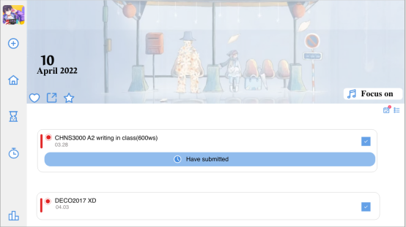（Before)

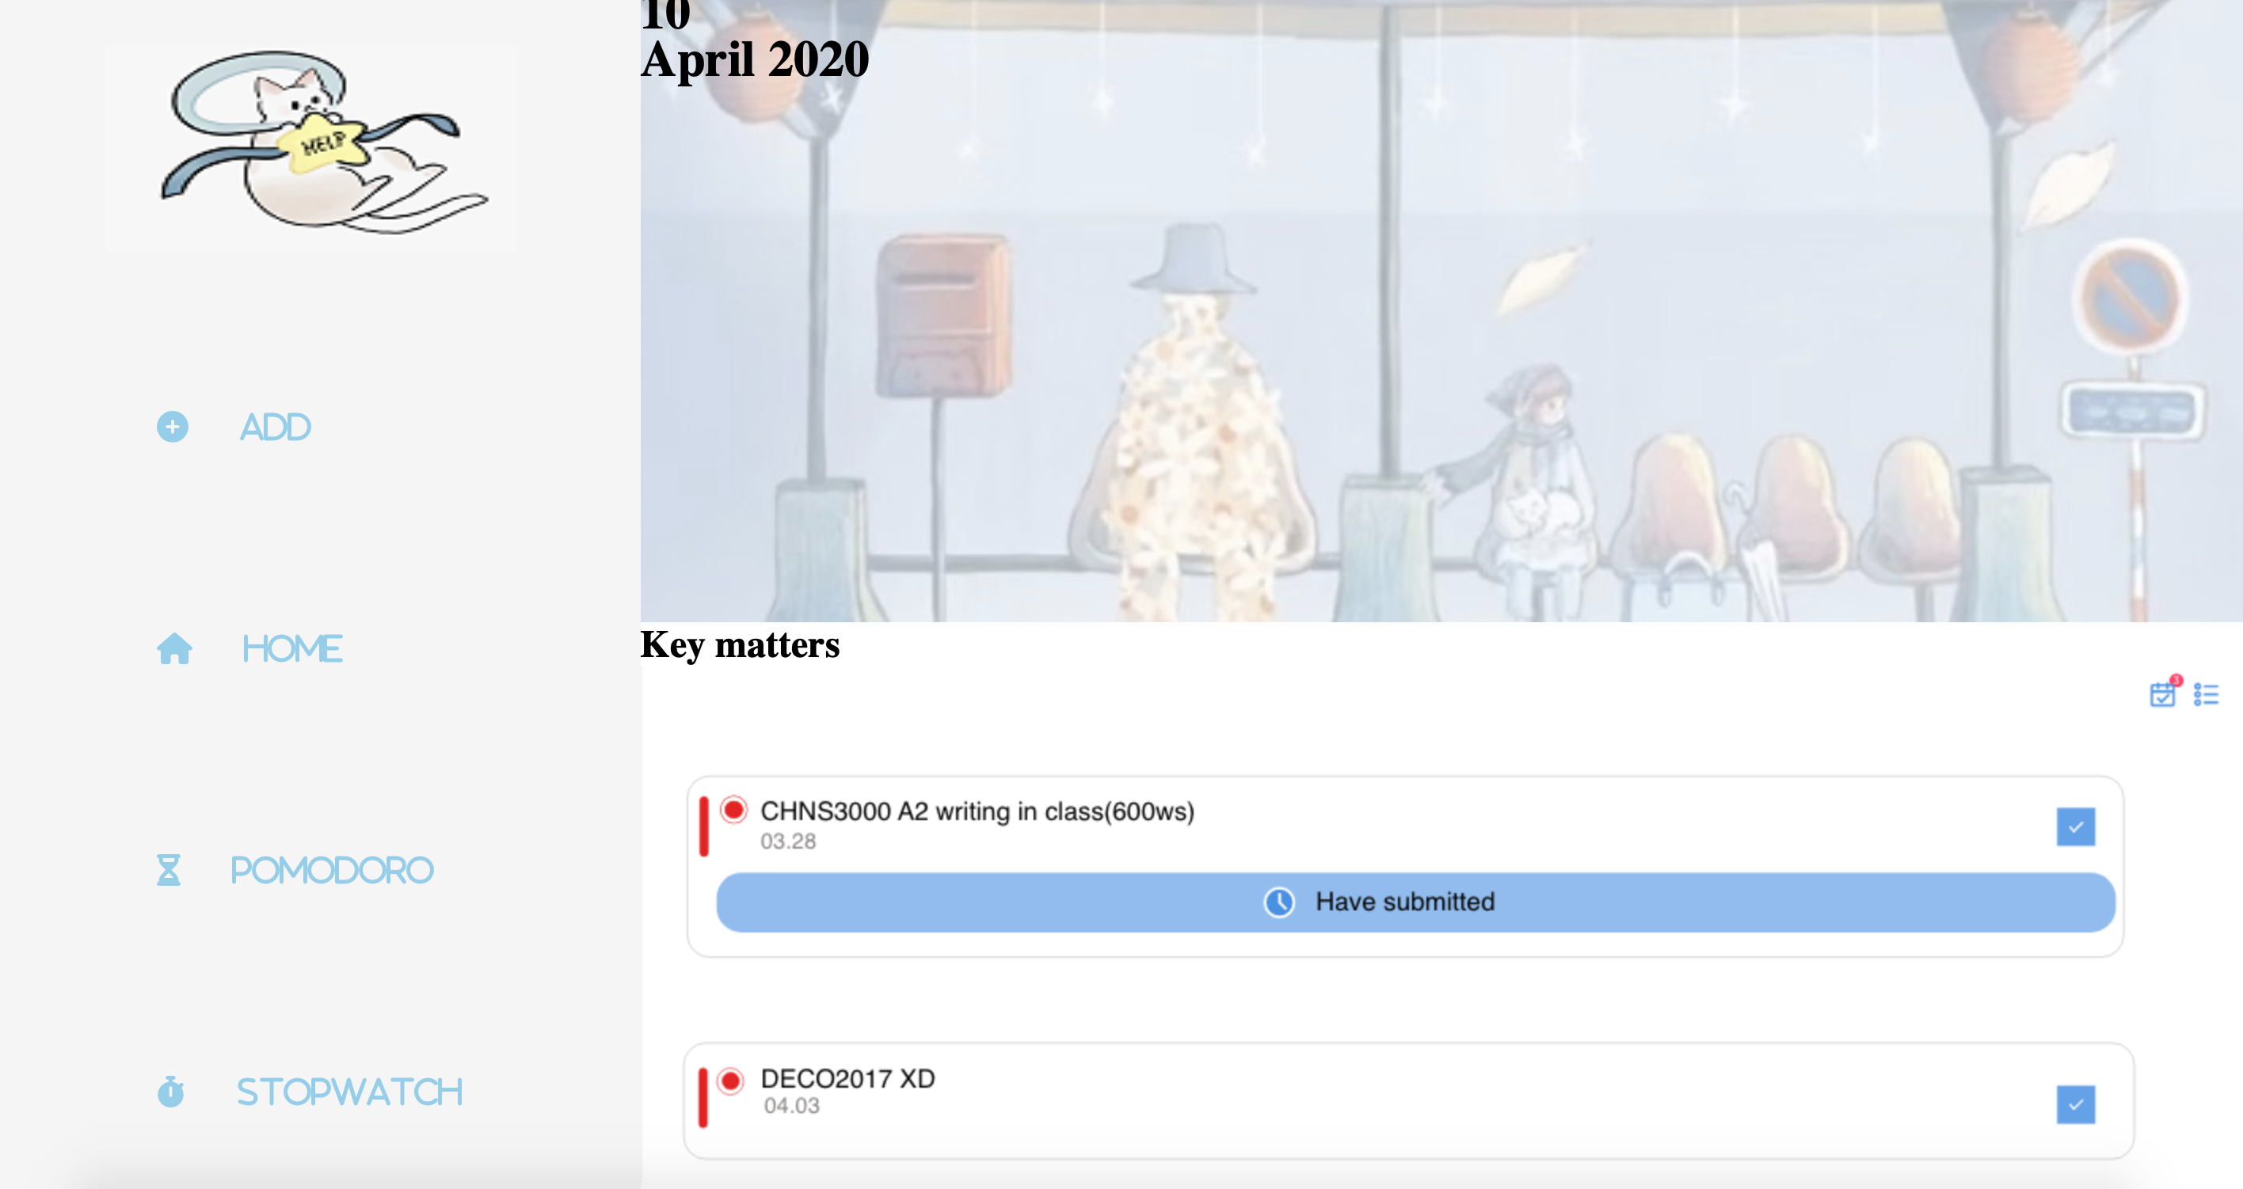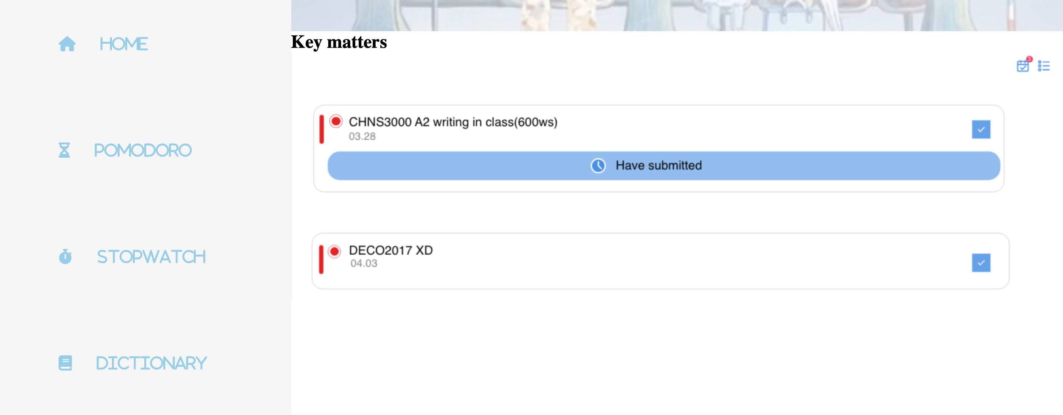（After)

Change points： 1. Remove the photo provided by the user login

2. Added logo

3. Highlight important features and enlarge them with text

Change reasons：The first reason to remove user profile pages is that 40 percent of respondents in the survey said that logging in and registering is a hassle. If only to experience, also need to register will reduce user comfort; Forgetting the password retrieval will take a lot of time. They want to be able to go to the web and start using it wherever they are. And the lack of logo on the original page makes users feel confused: what is the name of the app? How do I find it next time? To do this, I added the logo in the top right corner and enlarged it: 1. Easy to draw attention 2. More clearly understand the particularity of APP.

**2.Stop Watch**

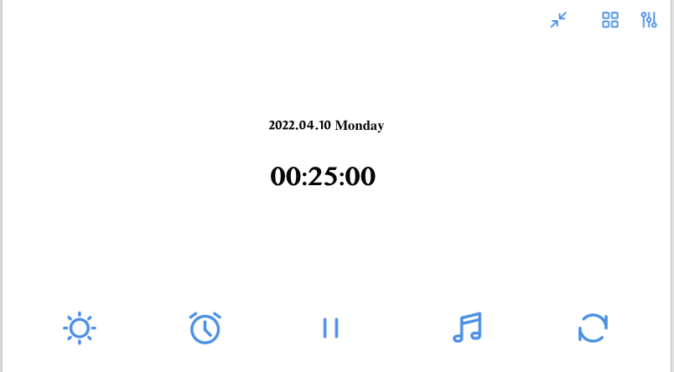(Before）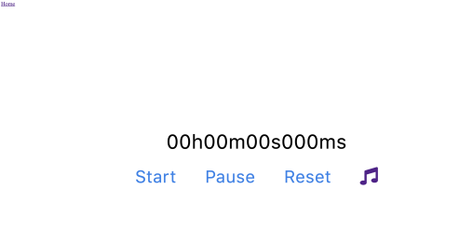（After)

Change points：1. Reduced the appearance of a large number of ICONS

2. Add text

3. Remove the date

Change reasons：First, deleting dates makes it easier for users to focus on numbers and time them successfully. Secondly, the appearance of a large number of ICONS on the page will make the user feel that the interface is complicated and confusing. There will also be a delay in contact. Therefore, after removing ICONS, important functions are retained and text instructions are added, so that first-time users can more directly understand the use and purpose of its functions. It also avoids the problem of accidentally clicking on other functions.

**3.Pomodoro**

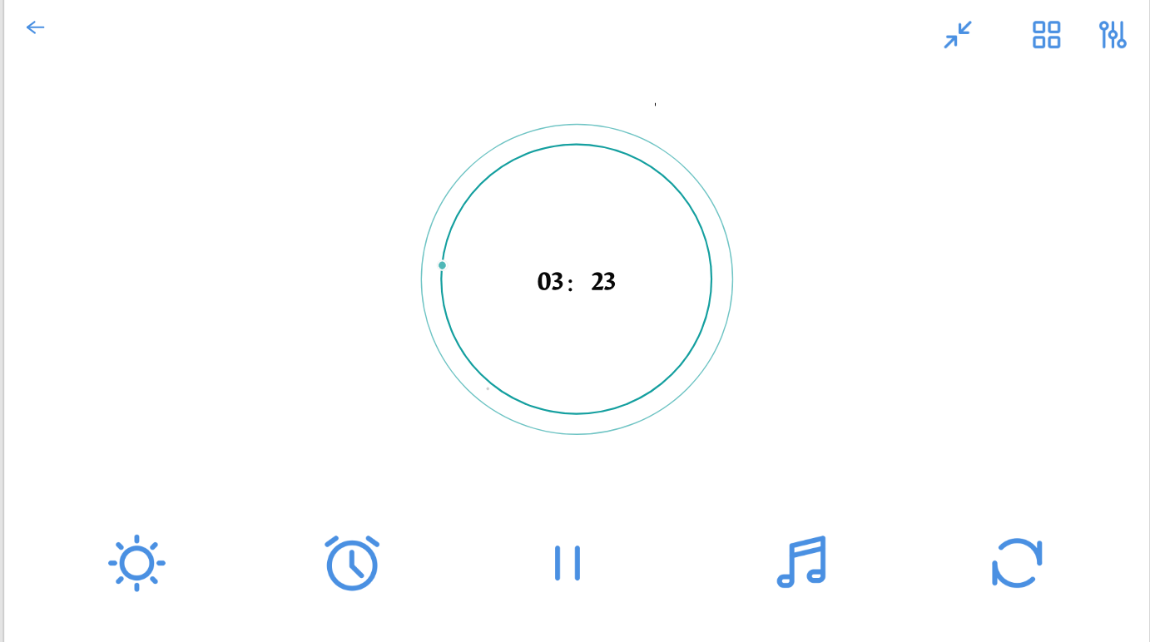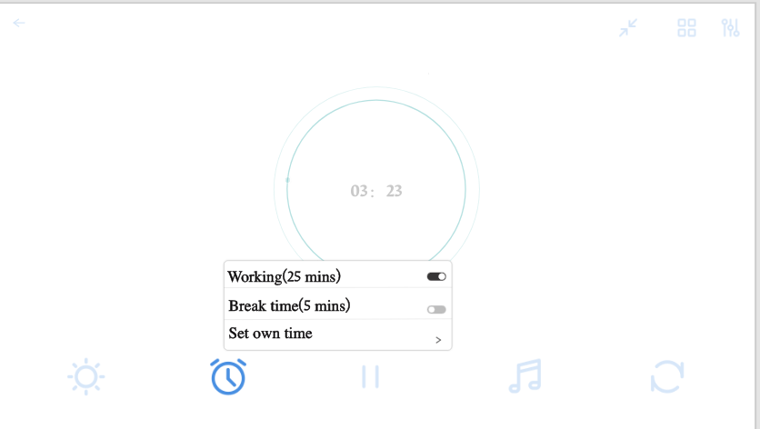(Before)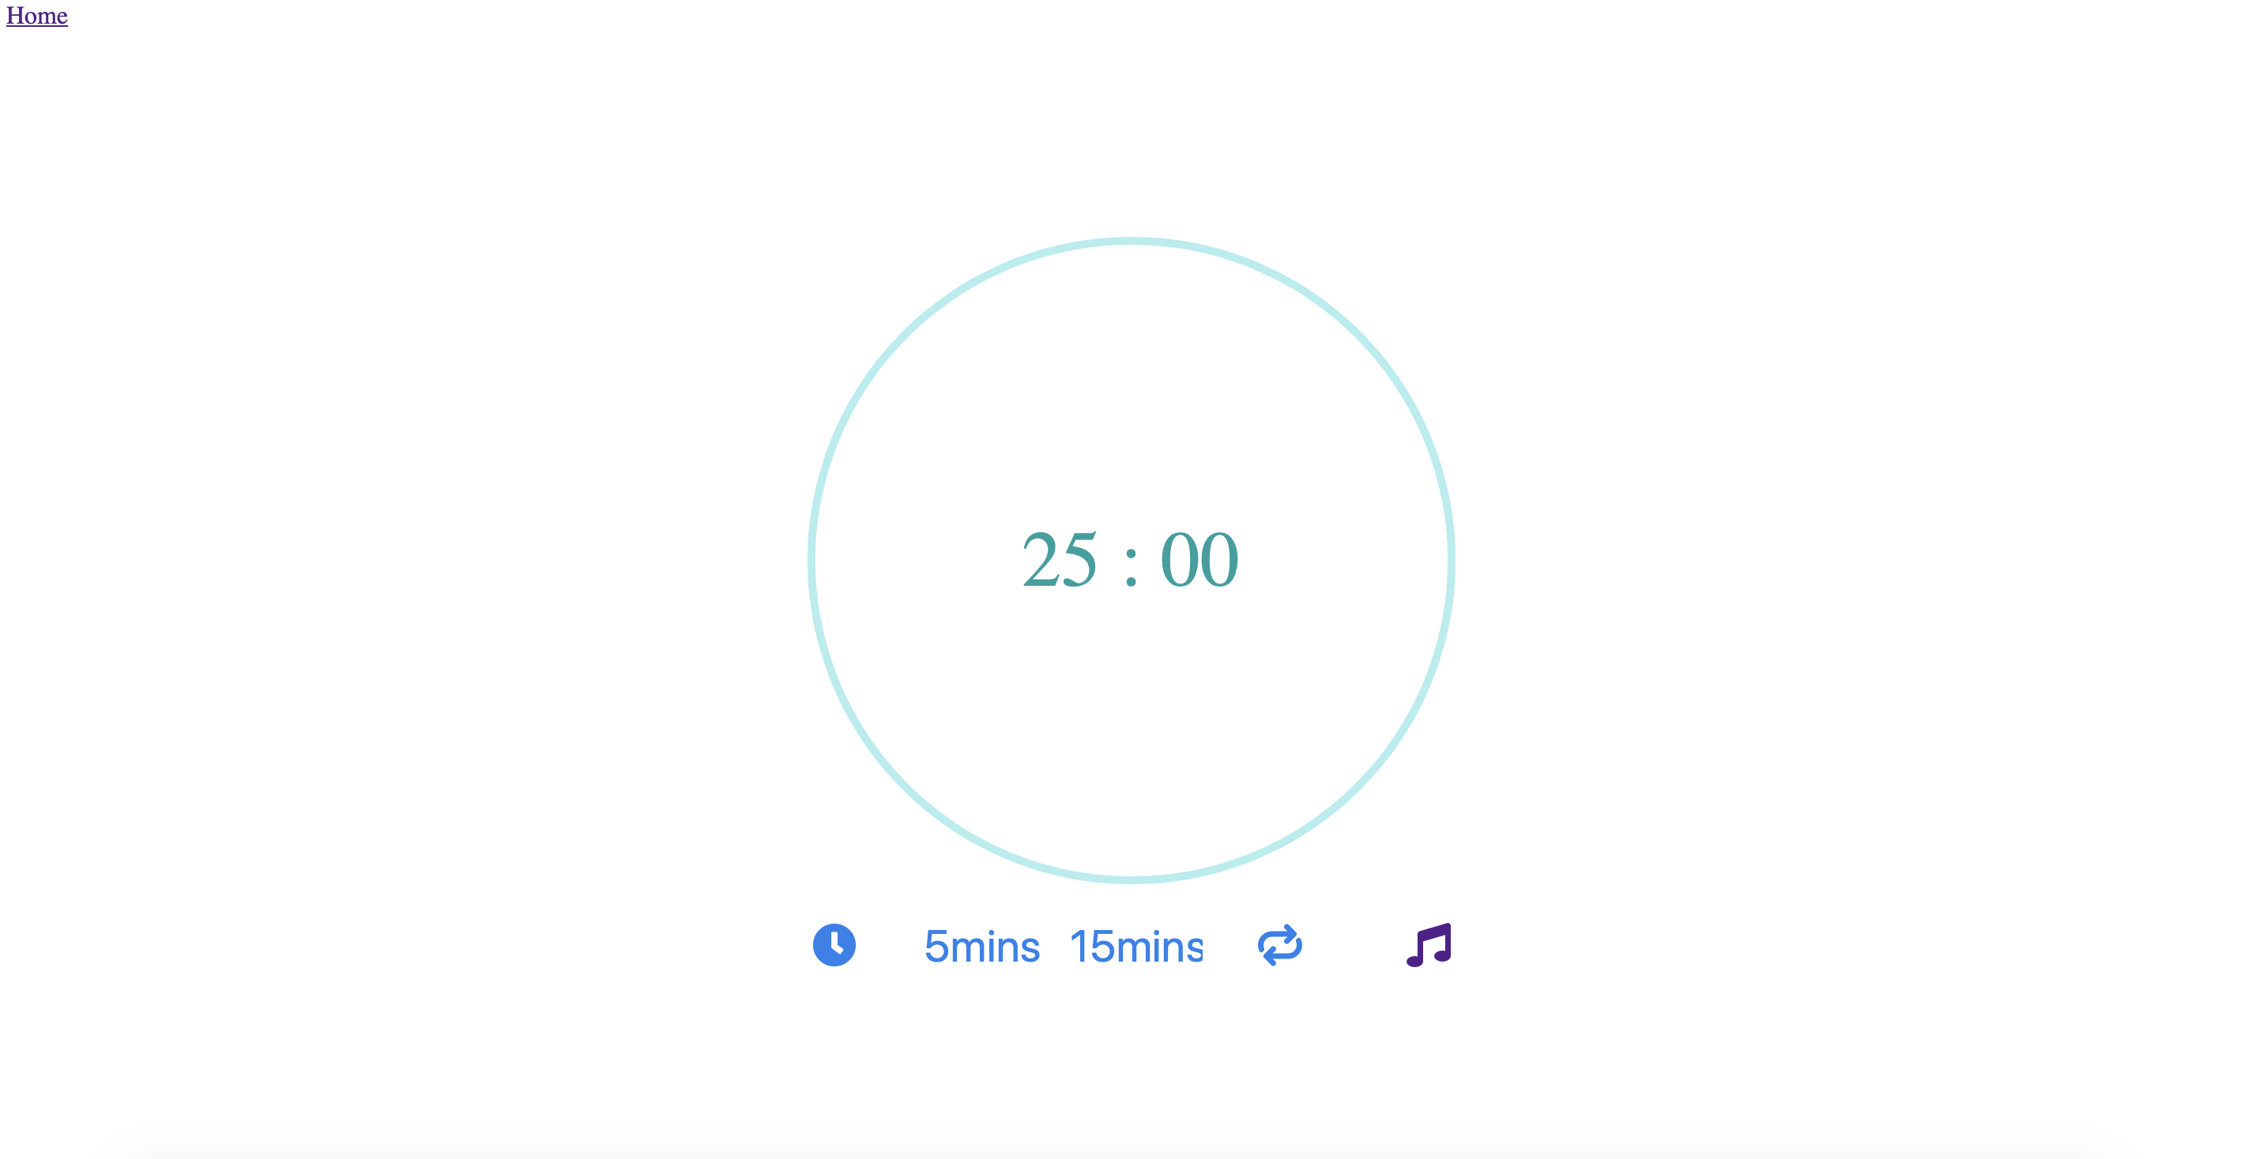（After)

Change points：1. Reduced the appearance of a large number of ICONS

1. Add text
2. Reduced the appearance of pop-up window frames

Change reasons：First, I reduced the problem of pop-ups on pages. Because the appearance of the popover frame often leads to users wanting to modify it, but they need to close it before they can use it. In order to reduce this time consumption, I put the rest periods (5mins/15mins) directly on the page. This behavior greatly increases the user's ease of use and simplifies the method of use. And I added text (5mins/15mins), so that users can more clearly understand the functionality of this.

**4.Dictionary**

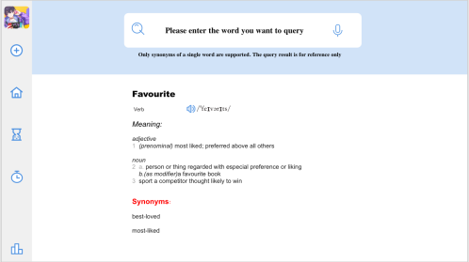(Before)

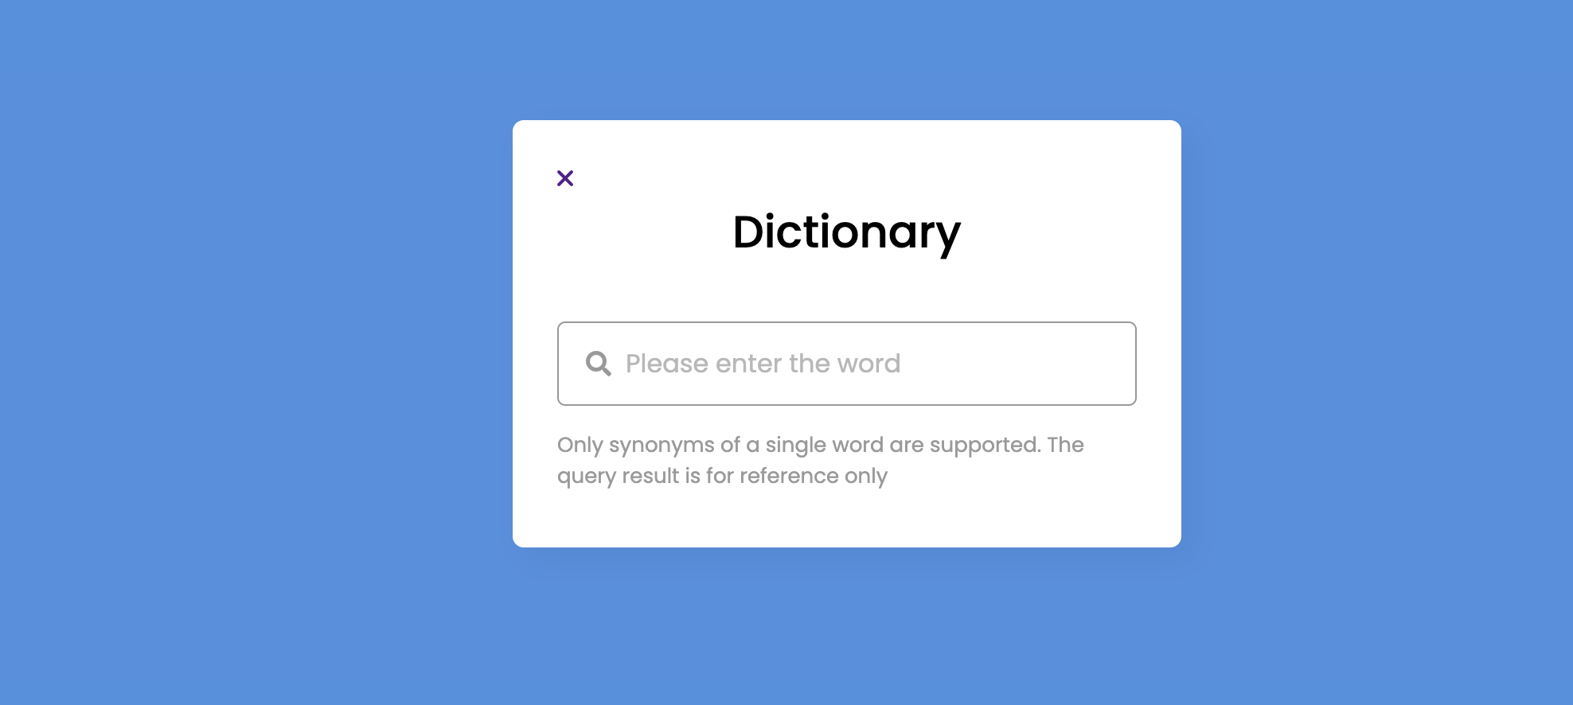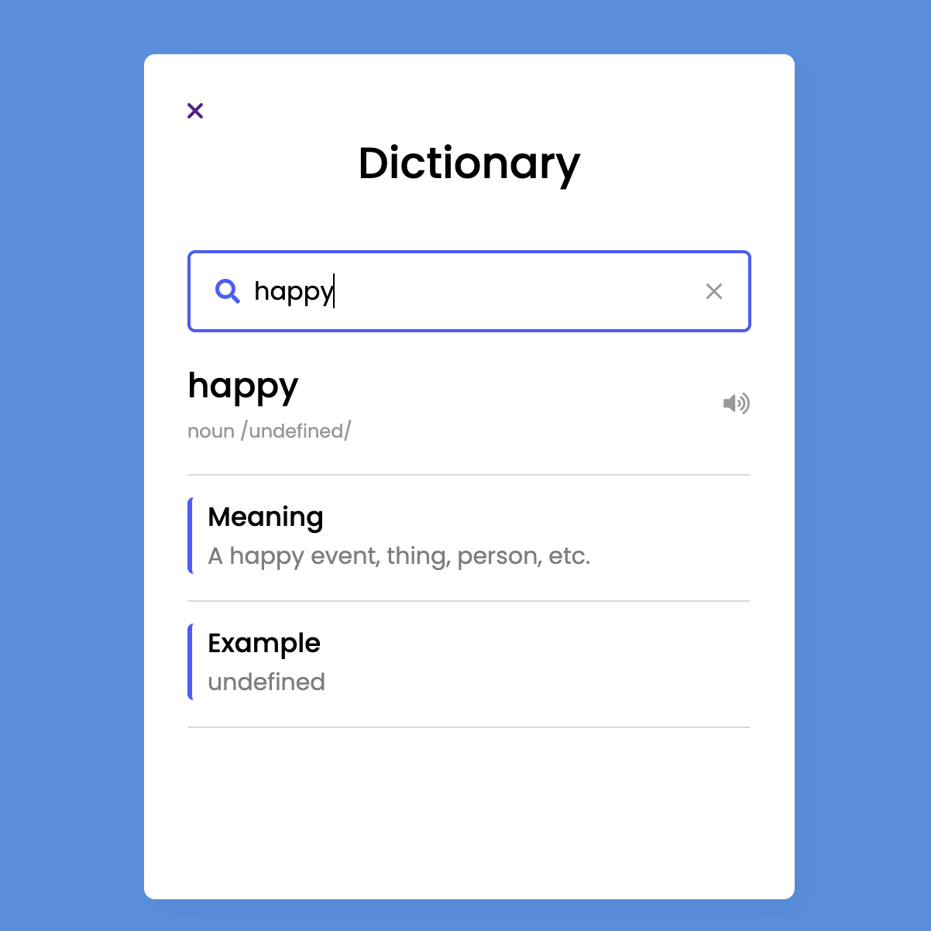 (After)

Change points：1.ncreased scaling

2.The absence of navigation bars

3.Reduced the appearance of pop-up window frames

Change reasons：First of all, the structure of the original page is not very aesthetically pleasing: there are a lot of gaps that are not aesthetically pleasing; Pages are less interactive. Second, the presence of a navigation bar creates misoperation problems. To this end, I simplified the navigation bar and added Home ButTom and page appearance. This allows users to find the dictionary more quickly, and also increases the interactivity of the page.

**5.Music**

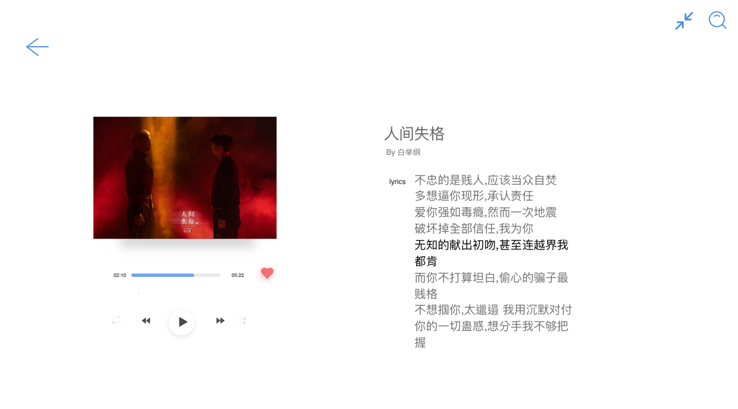(Before) 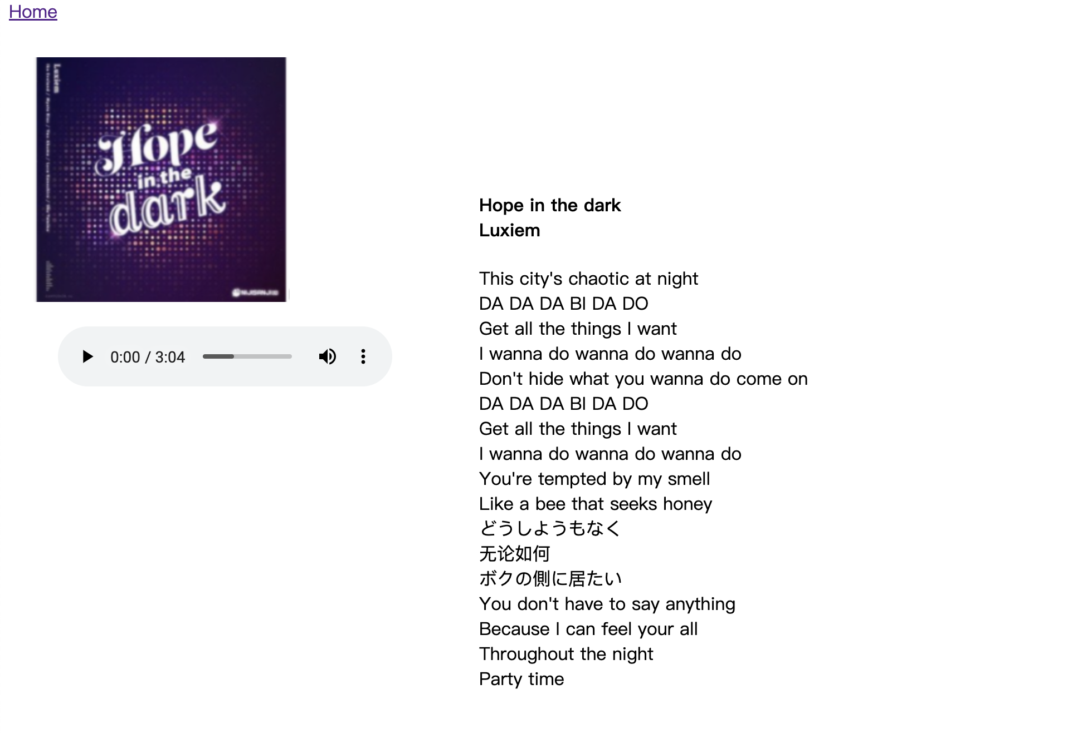(After)

Change points：1.Reduced clutter features

2.Changed the colour

Change reasons：Because adding a lot of ICONS leads to a cluttered and complex page, it also makes it harder to use. To this end, I reduced the input of ICONS and left them largely blank, allowing users to focus more on using music. Unfortunately, there are also two problems with the page that cannot be solved: 1. Unable to drag the progress bar 2. Lyrics can't scroll

1. **Calendar**

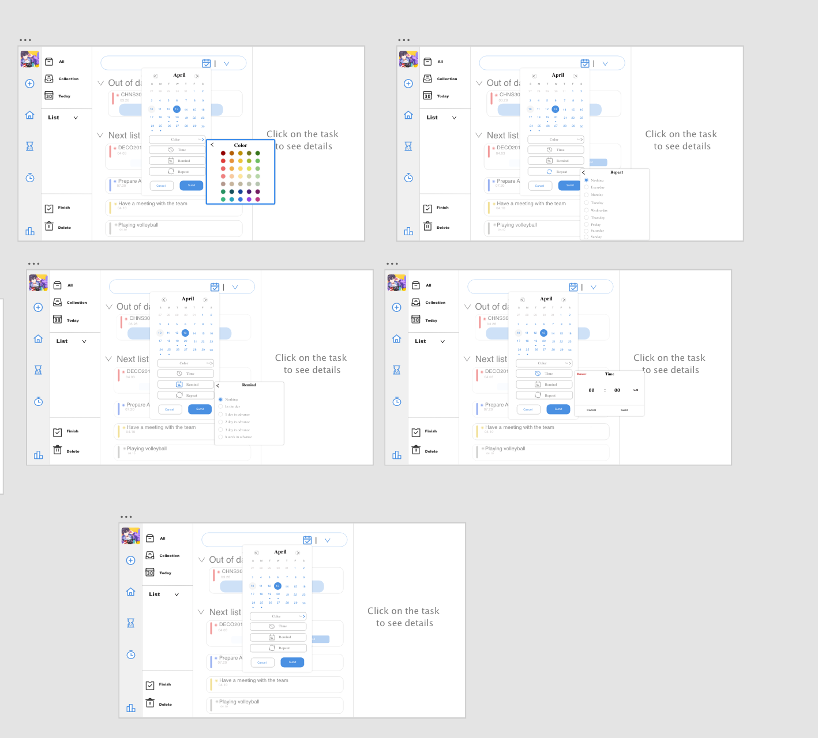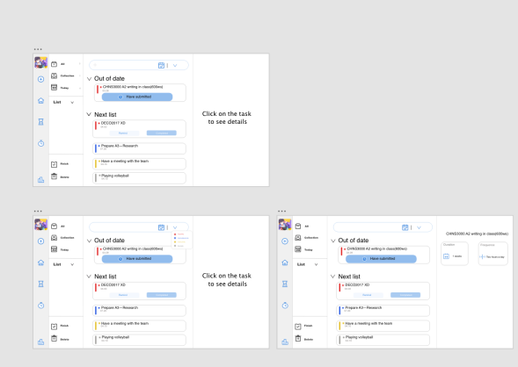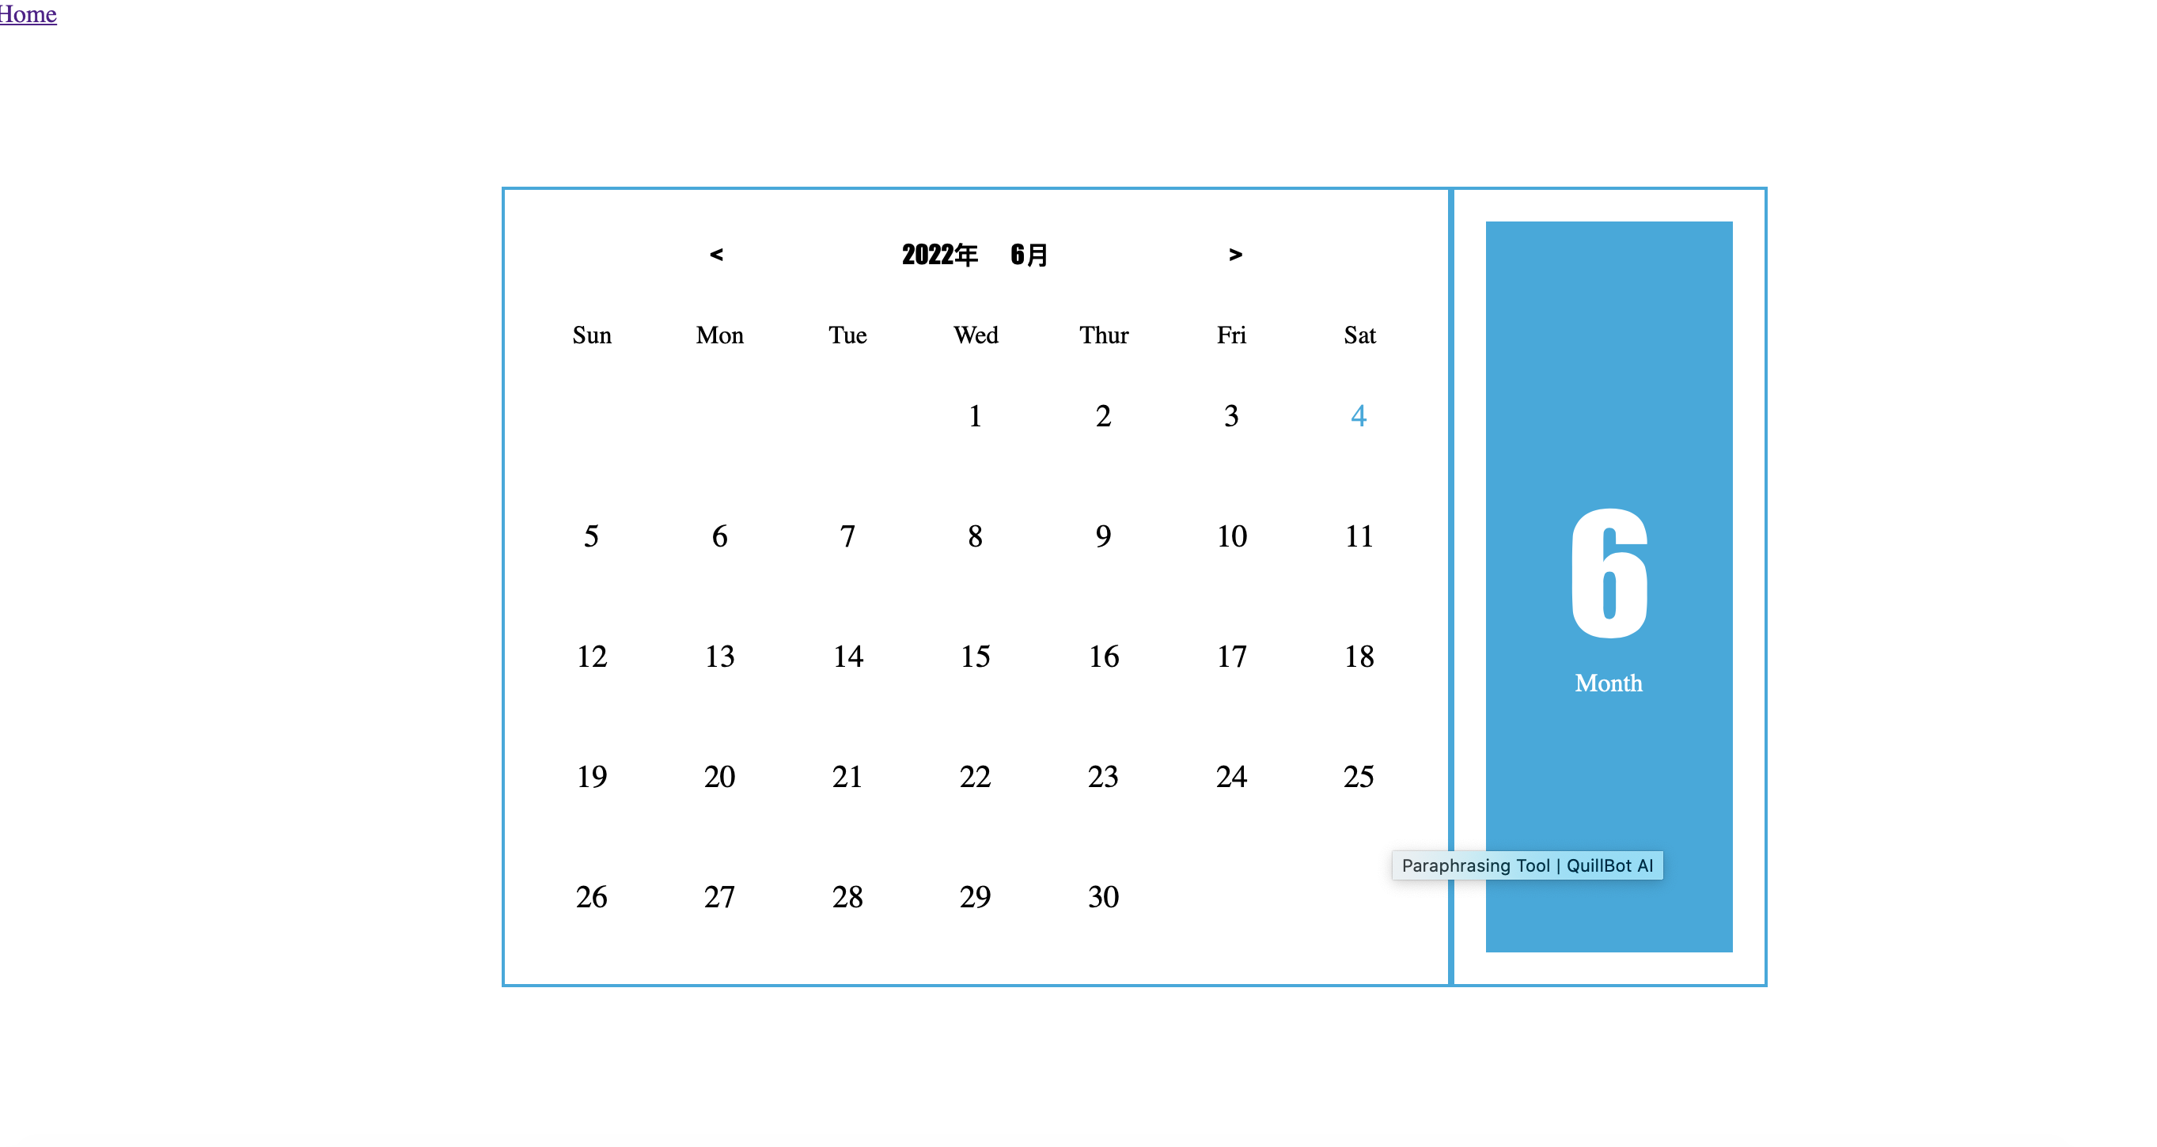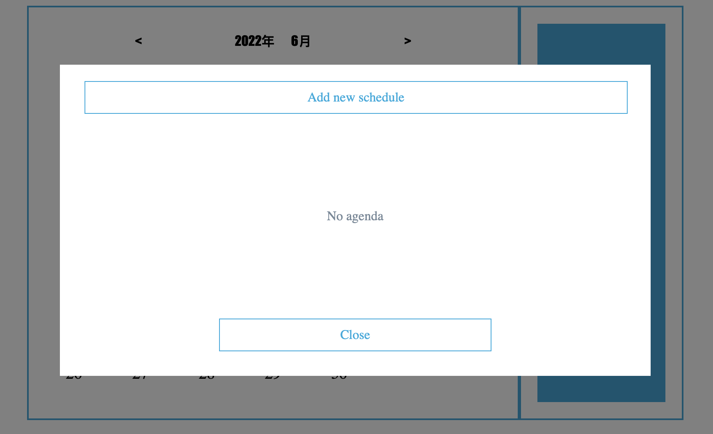

Change points：1.Reduced page complexity

2.Speed up the convenience of viewing

Change reasons：Users can directly click on the page date to record important items. When the user clicks on the date again after closing, the stored content is still visible. Different months can save different content, there will be no duplication. And there are blue numbers on the calendar that represent today's date. Greatly increased the aesthetic and convenient practicality

**The iteration**

First Iteration:

Problem: Content added on June 3rd will still be visible on July 3rd.

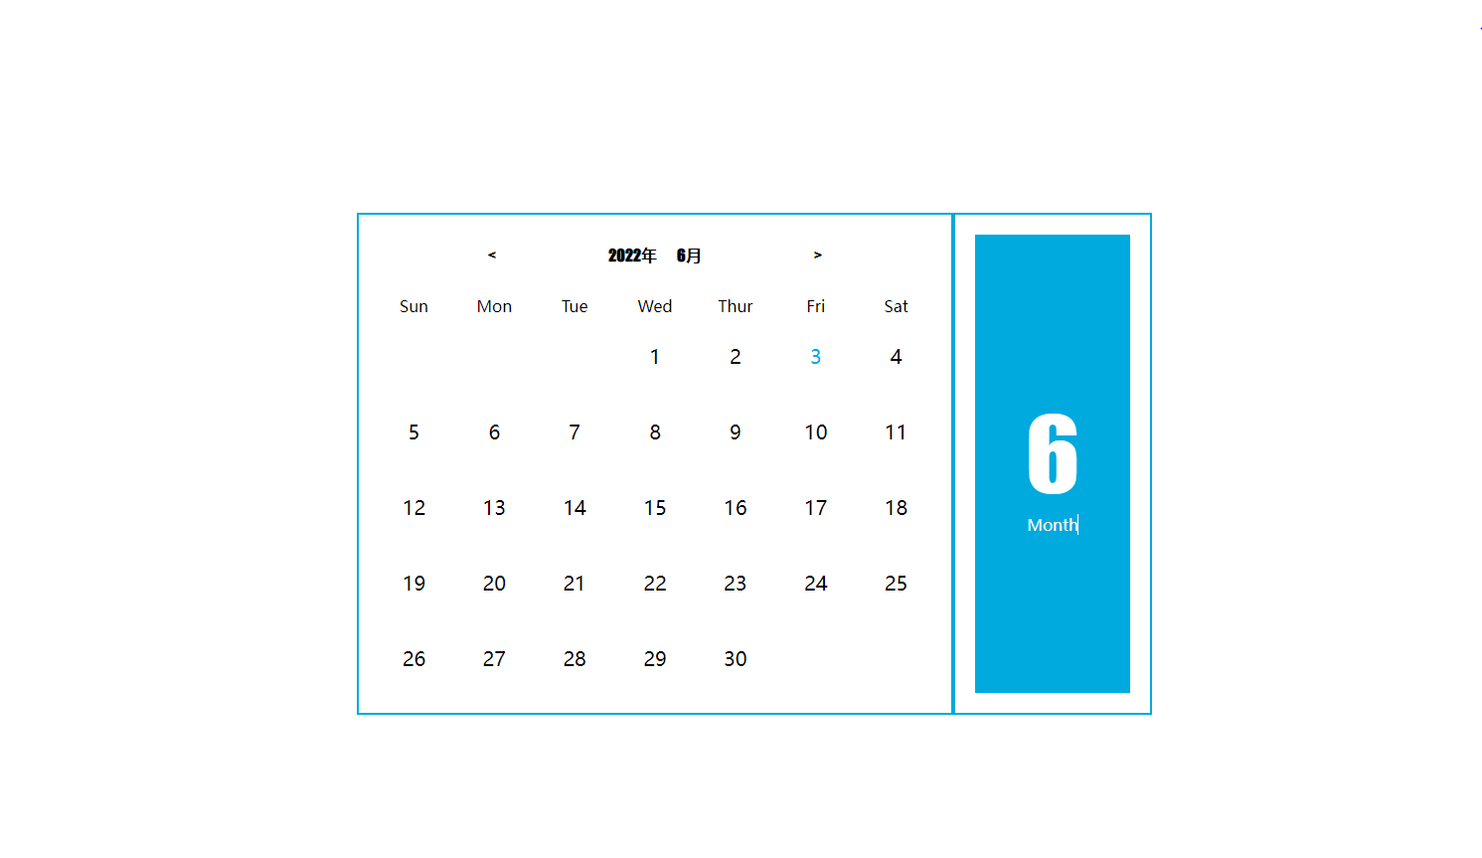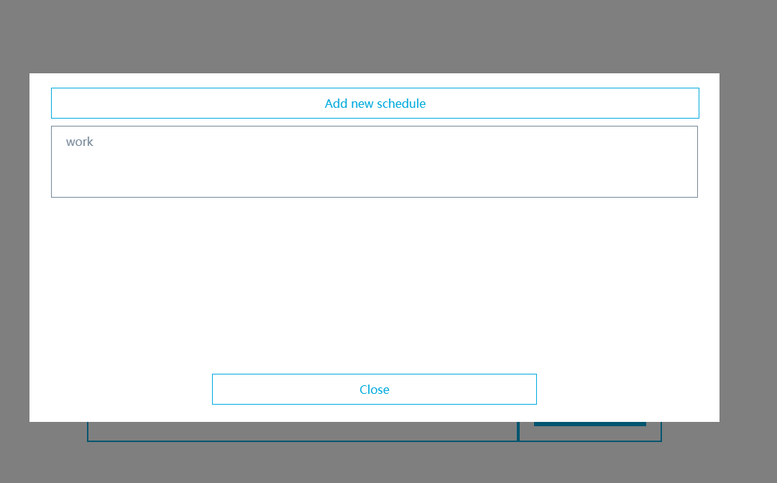

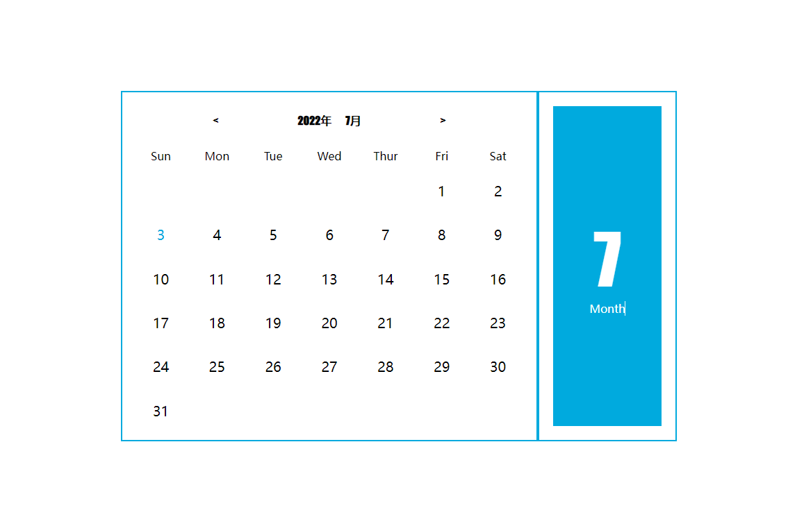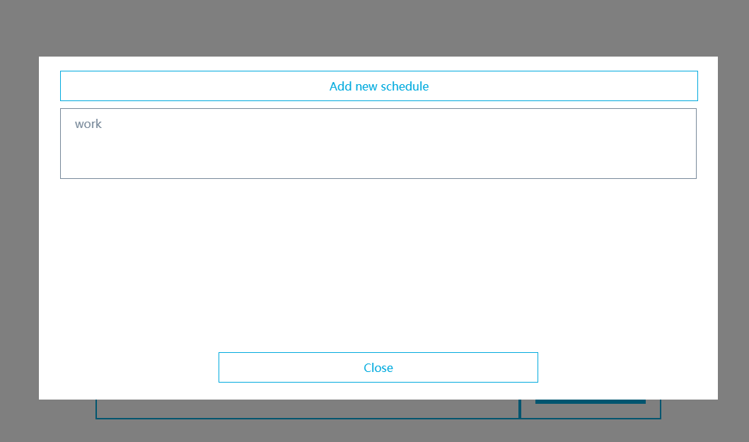

Changed: Content added on June 3rd will no longer be visible on July 3rd

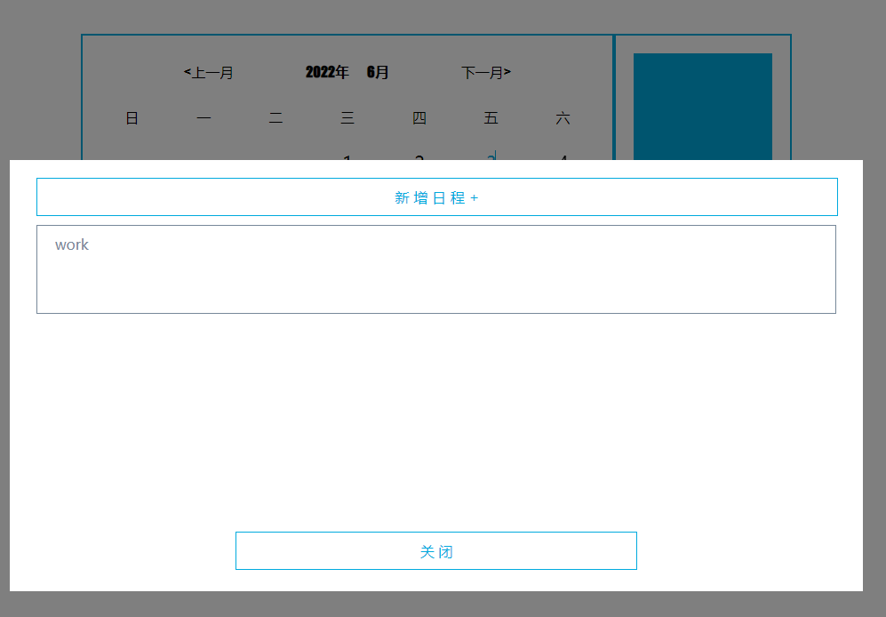 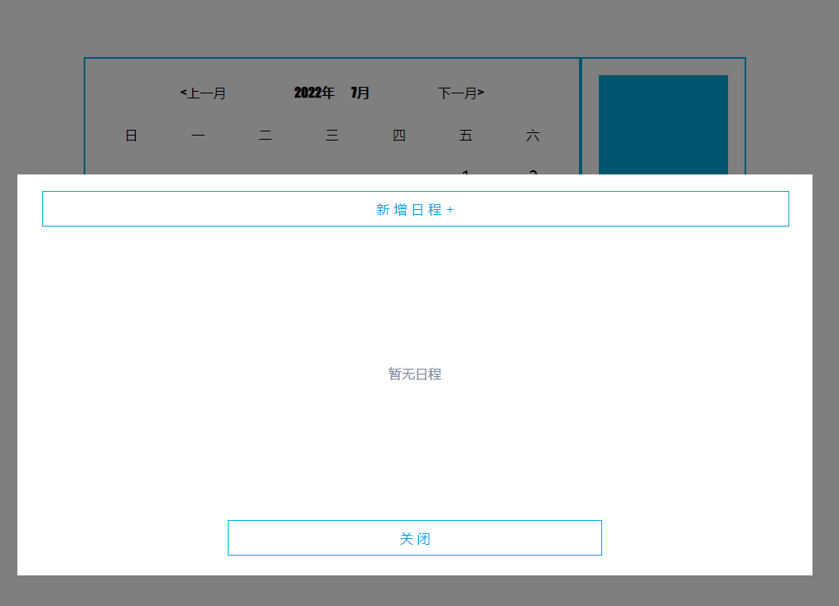

The second iteration:

Problem: Musical ICONS cannot be parallel Changed: Music symbols can now be parallel

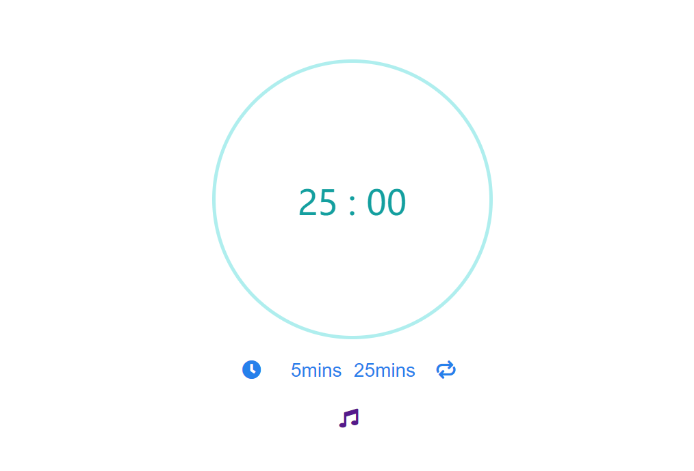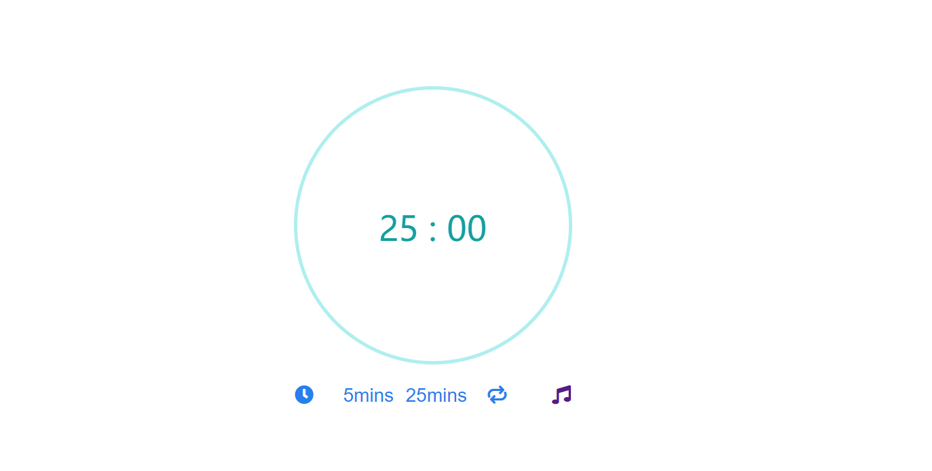

Third Iteration:

Problem: In Pomodoro the page shows the long break text as 25mins

Changed:The rest time is 5 minutes and 15 minutes respectively

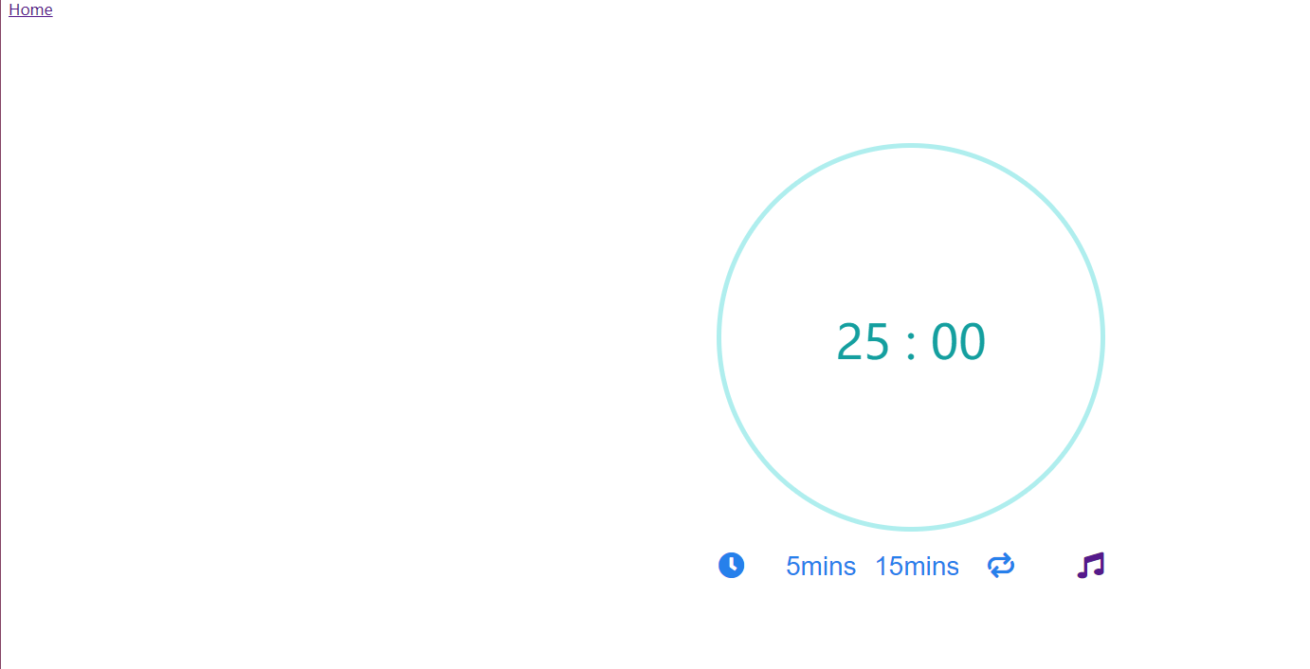

Problem: StopWatch found no jump to music page Modified: Added a switch button

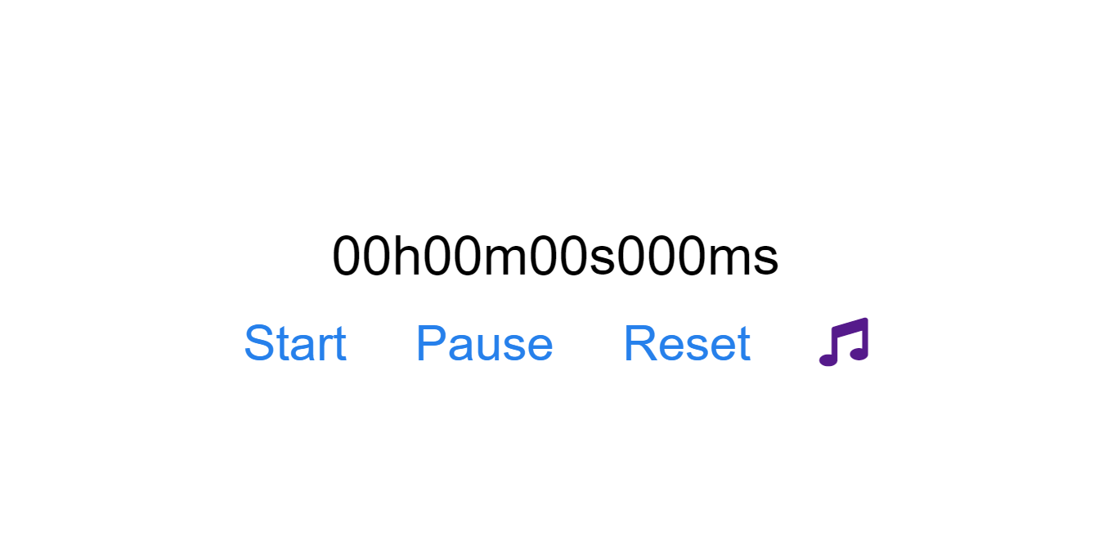

Fourth Iteration:

Problems: 1. Close arrow cannot move according to zoom 2. Pomodoro's back key fails

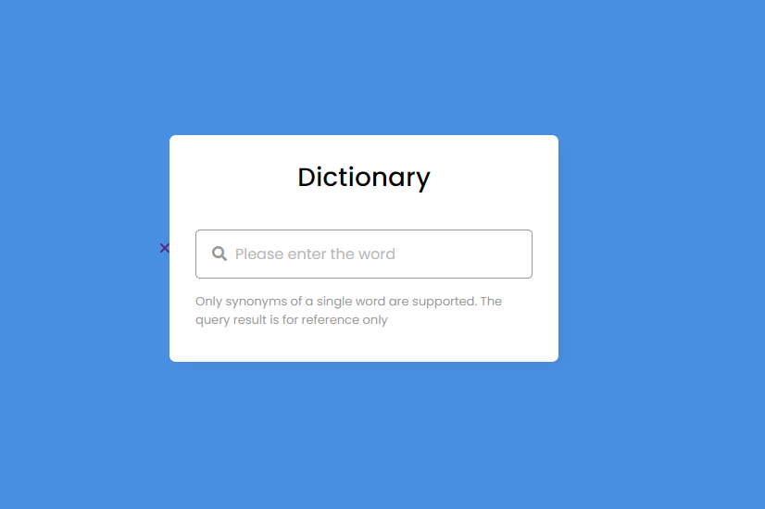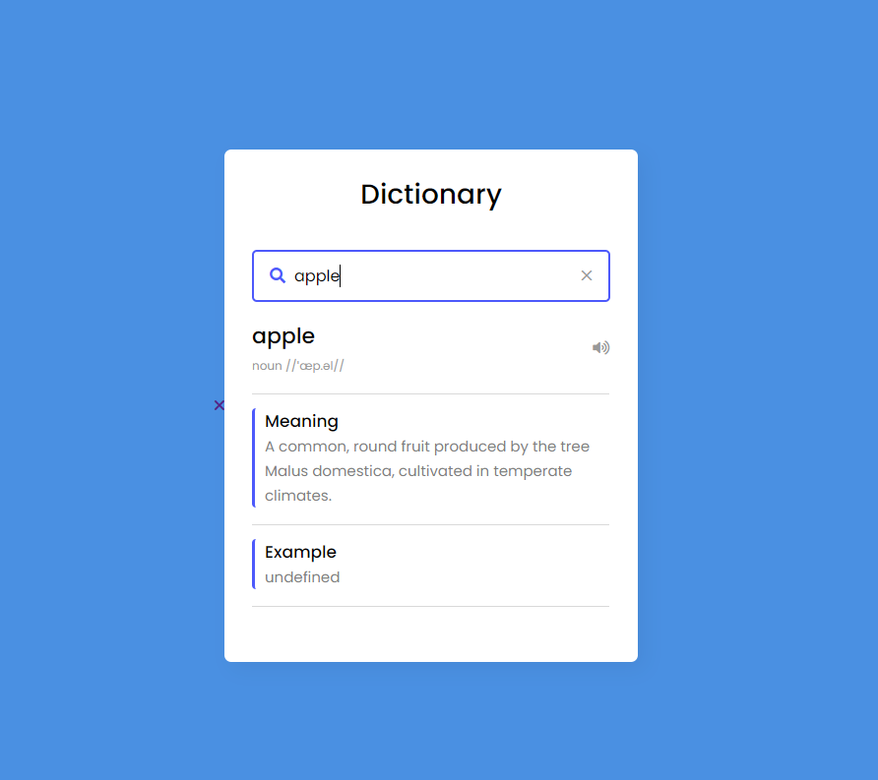

After modification: 1. Close the page and move as the page zooms in and out

1. The home button fails because of layers. You can jump to the home button

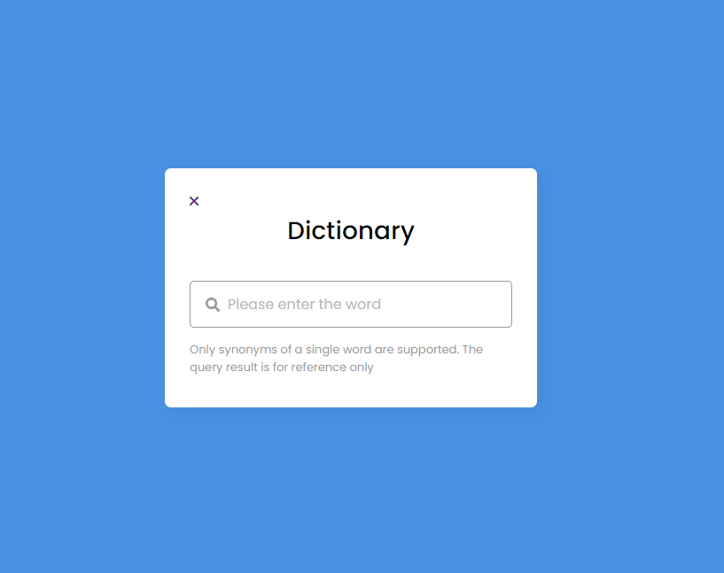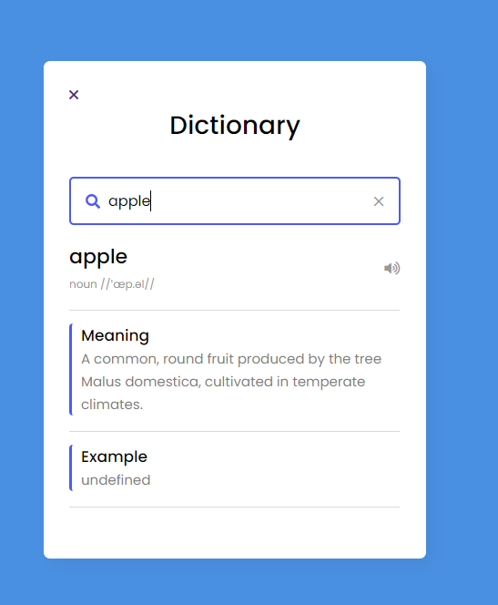

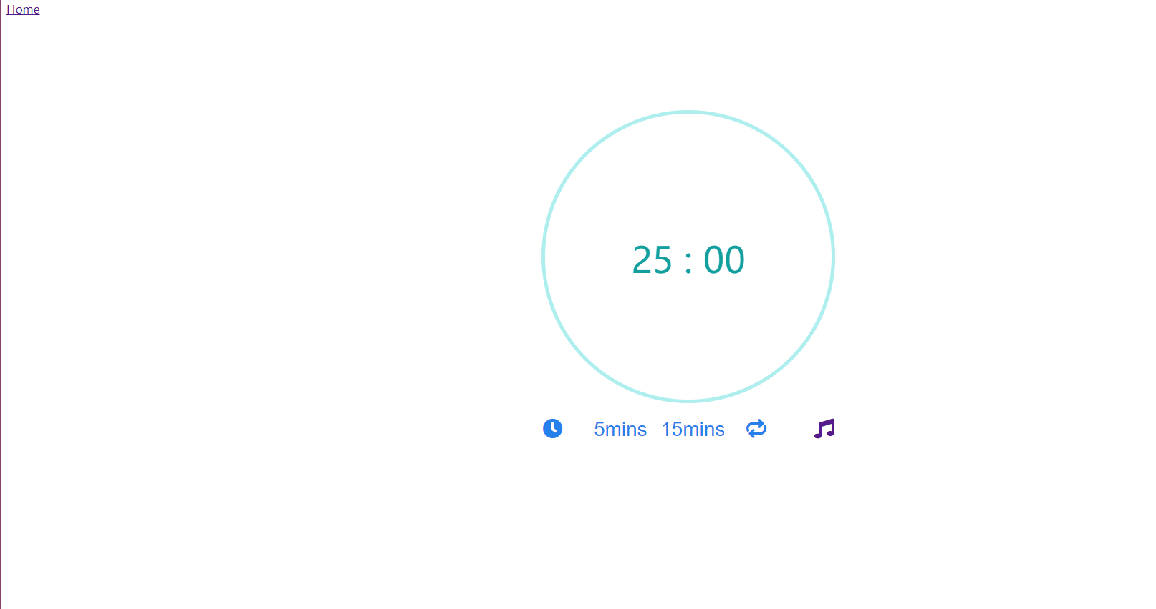

Fifth Iteration:

Music player, home page cannot be displayed





Reference：

1.2022. [online] Available at: <<https://codepen.io/rajdgreat007/pen/edvZpx>> [Accessed 4 June 2022].

2.[Cnblogs.com](http://Cnblogs.com). 2022. JavaScript原生秒表、计时器 - 晓晨Master - 博客园. [online] Available at: <<https://www.cnblogs.com/stulzq/p/4872887.html>> [Accessed 4 June 2022].

3. 2022. [online] Available at: <<https://www.codingnepalweb.com/build-dictionary-app-html-javascript/>> [Accessed 4 June 2022].